UPI SOUND NOTIFIER

ABSTRACT
UPI Sound Notifier is an Android application developed using React Native and Kotlin that detects UPI transaction notifications and provides customized audio alerts based on transaction status. The application monitors incoming notifications, analyzes their content, and classifies them into categories such as Money Received, Money Sent, and Payment Failed. Based on the identified transaction type, the application plays a corresponding sound alert, allowing users to instantly recognize transaction outcomes without checking their phones. This project demonstrates the integration of mobile application development, Android notification handling, pattern matching, and media playback functionalities.

1. INTRODUCTION
The rapid adoption of digital payment platforms such as PhonePe, Google Pay, and Paytm has significantly increased the volume of transaction notifications received by users. However, most smartphones use similar notification sounds for all applications, making it difficult to distinguish financial transaction notifications from regular alerts.
UPI Sound Notifier addresses this challenge by providing customized sound notifications for different transaction outcomes. The application detects UPI transaction notifications and plays unique audio alerts based on whether money was received, money was sent, or a payment failed.

2. OBJECTIVE
The primary objectives of this project are:
- To detect incoming UPI transaction notifications in real time.
- To classify notifications into Money Received, Money Sent, and Payment Failed categories.
- To extract transaction-related information from notification content.
- To provide customized audio alerts for different transaction types.
- To improve user convenience and awareness of financial transactions.

3. PROBLEM STATEMENT
Most Android devices generate identical notification sounds for various applications, making it difficult for users to identify important financial transactions instantly.
For example:
- Money received through PhonePe
- WhatsApp message
- Instagram notification
- Promotional message
may all produce similar notification sounds.
Users must unlock their phones and manually check notifications to determine their importance. This project aims to solve this issue by introducing transaction-specific audio alerts.

4. TECHNOLOGY STACK

Frontend

React Native
Purpose:
- Building the application interface.
- Managing application screens.
- Providing a cross-platform development environment.
Advantages:
- Single codebase.
- Faster development.
- Reusable components.

Native Android Layer

Kotlin
Purpose:
- Handling Android-specific functionality.
- Implementing notification detection logic.
- Managing custom sound playback.
Advantages:
- Official Android language.
- Improved safety and performance.
- Easy integration with Android APIs.

Android Components Used

NotificationListenerService
Purpose:
- Monitors incoming notifications.
- Reads notification title and content.
- Detects UPI transaction notifications.

MediaPlayer
Purpose:
- Plays custom audio files.
- Generates different sounds for different transaction types.

Tools Used
- Visual Studio Code
- Android Emulator
- Android Debug Bridge (ADB)
- Logcat
- Git
- GitHub

5. SYSTEM ARCHITECTURE
UPI Notification
↓
Notification Listener
↓
Notification Content Analysis
↓
Transaction Classification
↓
Amount Extraction
↓
Custom Sound Playback
↓
User Alert

6. PROJECT MODULES

Module 1: Notification Detection
This module continuously monitors incoming Android notifications using NotificationListenerService.
Functions:
- Capture notification title.
- Capture notification text.
- Read notification content.
Input:
UPI notification
Output:
Notification content for processing.

Module 2: Notification Classification
The application analyzes notification text and classifies it into one of the following categories:
- Money Received
- Money Sent
- Payment Failed
Example:
Input:
"₹500 received from Rahul"
Output:
Money Received

Module 3: Amount Extraction
This module extracts transaction amounts using pattern matching techniques.
Examples:
Input:
₹500 received
Output:
500
Input:
₹1,000 sent
Output:
1000

Module 4: Custom Sound Playback
The application uses different audio files for different transaction types.
Audio Files:
- money_received.wav
- money_sent.wav
- payment_failed.wav
MediaPlayer loads and plays the corresponding sound based on classification results.

7. IMPLEMENTATION
The application was developed using React Native and Kotlin.
Implementation steps:
- Created Android notification listener service.
- Enabled notification access permissions.
- Captured notification content.
- Implemented notification classification logic.
- Added transaction amount extraction.
- Integrated custom sound playback.
- Tested functionality using Android Emulator and ADB commands.
- Validated output through Logcat debugging.
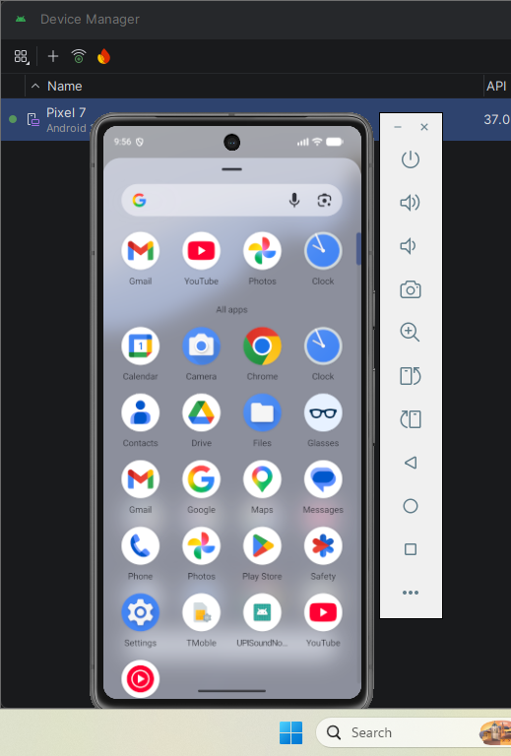
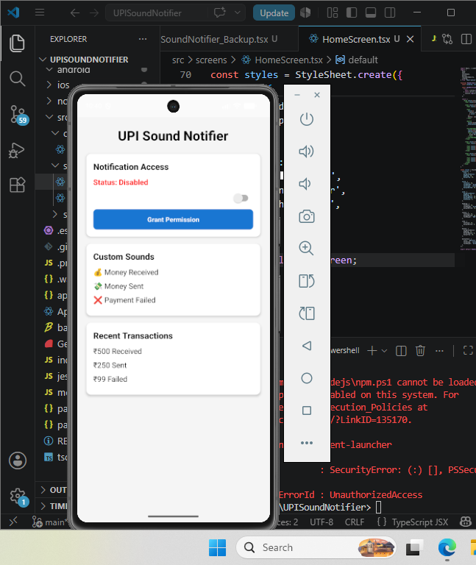

8. CHALLENGES FACED

Challenge 1: Notification Access Configuration
Problem:
Android restricts applications from accessing notifications by default.
Solution:
Configured NotificationListenerService and manually enabled notification access permissions.

Challenge 2: Service Registration Issues
Problem:
The notification listener service was initially not receiving notifications.
Solution:
Verified AndroidManifest configuration and corrected service registration settings.

Challenge 3: Notification Testing
Problem:
Test notifications did not always provide expected results.
Solution:
Used ADB commands and Logcat debugging to inspect notification content and verify application behavior.

Challenge 4: Audio Playback Integration
Problem:
Custom sounds were not playing correctly during initial testing.
Solution:
Configured MediaPlayer properly and stored audio resources in the Android raw resource directory.

Challenge 5: Debugging and Validation
Problem:
It was difficult to determine whether issues originated from notification detection or audio playback.
Solution:
Implemented detailed Logcat logging and tested each module independently to isolate and resolve issues.

9. RESULTS
The application successfully:
- Detects UPI transaction notifications.
- Identifies transaction types.
- Extracts transaction amounts.
- Plays customized audio alerts.
- Provides instant transaction awareness.
Sample Outputs:
- Money Received → Custom Success Sound
- Money Sent → Custom Send Sound
- Payment Failed → Custom Failure Sound

10. APPLICATIONS
- Personal finance monitoring.
- Instant transaction awareness.
- Accessibility support for users.
- Customized financial notification systems.
- Mobile payment alert systems.

11. FUTURE ENHANCEMENTS
Future improvements may include:
- Transaction history dashboard.
- User-configurable sound profiles.
- Google Pay and PhonePe specific detection.
- Local database storage.
- Transaction analytics.
- Cloud synchronization.
- Enhanced user interface.

12. CONCLUSION
UPI Sound Notifier successfully demonstrates how Android notification monitoring can be combined with customized audio alerts to improve user experience. The application detects UPI transaction notifications, classifies them into meaningful categories, extracts transaction-related information, and provides transaction-specific sound alerts. The project showcases practical implementation of React Native, Kotlin, Android notification handling, debugging techniques, and media playback integration while solving a real-world problem.

